MINISTRY OF EDUCATION AND SCIENCE OF UKRAINE

NATIONAL TECHNICAL UNIVERSITY

«KHARKIV POLYTECHNIC INSTITUTE»

Department of Software Engineering and Management Information Technologies

Report from lab № 8

discipline «Fundamental of Databases»

Completed by: **CHUKWU IRELE**

student of group: **1.KH201.8ei**

Checked by**: Assistant Polovinka O.L.**

**TOPIC :**LEARN DBMS ACCESS REPORT DEVELOPMENT TOOLS

**Goal:** State the laboratory practice problem. Study how to MERGE ALL CREATED COMPONENTS TOGETHER AND CREATE APPLICATION. LEARN BASICS OF INFORMATION SECURITY IN DBMS ACCESS

**Create “Data” form:**

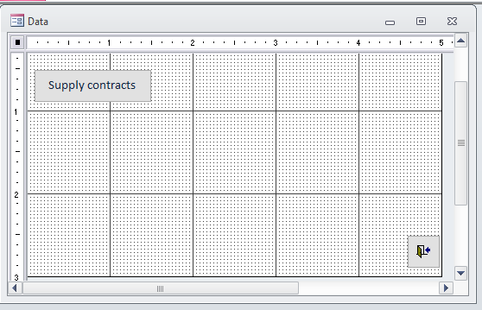

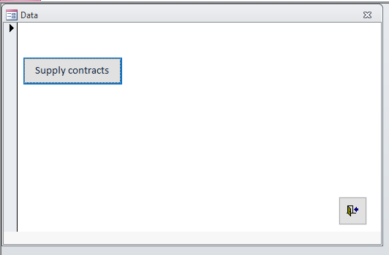

**Create “Data processing” form:**

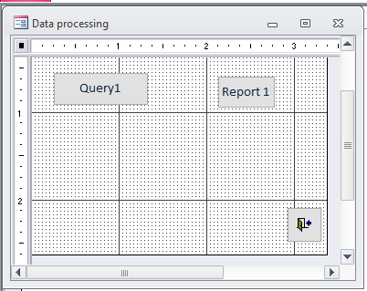

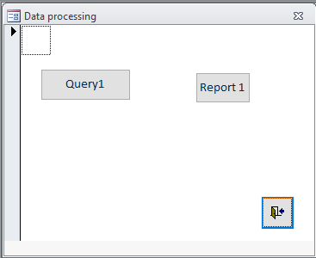

1. **Create “Main” form.**

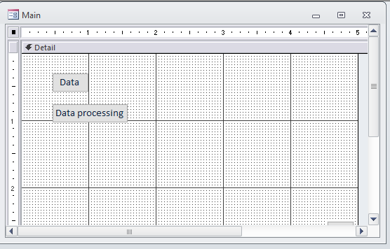

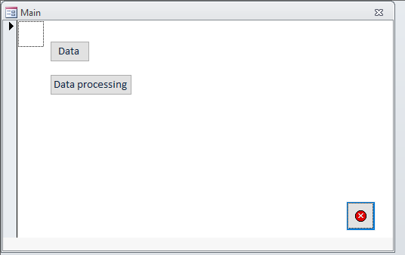

**Setup password :**

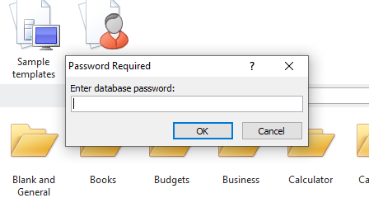

**Conclusion :**

At that lab were received knowledge about how to MERGE ALL CREATED COMPONENTS TOGETHER AND CREATE AN APPLICATION. LEARN BASICS OF INFORMATION SECURITY IN DBMS ACCESS BY SETTING A PASSWORD FOR OUR DATABASE